2021
Car Specifications
Wall Sunday Series MRL Microstocks

Microstocks are open-wheel modified stockcar inspired go-karts, and race on paved and dirt oval tracks. They are larger than open style karts and feature bodies, full roll cages and seat belts.
Racing kart style one cylinder 4 cycle engines are used for power. There are several classes for loads of affordable fun!

Contact Information
For more information, explanations, to schedule a race or speak to someone please contact one of the below members of the MRL.

Bob Wagner
Jeff Weinacker
Harry Burd

Disclaimer
....The MRL, the MSRS or any iteration of this group, this set of rules, its publisher and all contributors will not be held responsible for any injuries. It is the car owner and drivers responsibility to ensure their own safety. This set of rules is as a general set of guidelines and each division racing will have slightly different rules and each track will have different Tech and safety rules. Check with your local track and Tech officials for more detailed information.
By building and or Racing any form of car or Microstock the builder and driver will assume all responsibility.

* Mission Statement *
Microstock Racing presents an opportunity for men and women to share their passion for auto racing in an atmosphere of friendship and camaraderie.
Rules and guidelines shall be established to provide fair competition at a reasonable cost. However, sportsmanship, friendship and fun shall be the primary goal of each race day.

BASIC RULES
- State regulations shall be met in any State where a race is conducted.
- The primary engine package for WF shall be the World Formula sealed by J.C. Specialties.
- The primary engine package for LO-206 shall be a the LO-206 sealed by Briggs and Stratton.
* Note: Wall speedway is primarily World Formula powered cars.
- Minimum weight of car and driver shall be 475 pounds.
- Maximum width 49" measured outside/outside anyplace parallel with rear axle.
- Maximum length of 96" bumper to bumper
- Maximum height of 42 inches. (More detailed rules follow)

LOCAL GROUP PROCEDURES
There are several major groups of Microstock Racers. Any group wishing to race at a track regularly attended by another group shall contact the regulars as a courtesy before contacting the local promoter.

The rules and procedures of the local group shall prevail. However, the visitors may score themselves separately and pay out as they choose. Under no circumstances shall a visiting group exclude the local group from participation.

RACING
- No Microstock shall be denied the opportunity to race. If the car does not meet the engine rules, they shall be allowed to start last and not be officially scored. An identifying ribbon may be required. Every opportunity to increase the field of cars shall be taken.
- World Formula races, Modified (MOM) cars [2 or less] shall be permitted to race from the front of the field for safety. Any LO-206 cars will start in the rear also for safety.
- Winners of previous races shall start no better than 10th in their next feature race. Local track rules may require an invert based on car counts. All competitors shall know prior to heat races what sort of inversion or re order will be done, but not exact details.
- Any non-points race held at a local track shall be governed by the local rules.

Table of Contents

- Points System

- Motor Packages/Classes

- Flagging

- Racing Procedures Heats
Feature Line Up Post Race Inspection Penalties
Three Driver Panel 5 Driver Safety
6 Car Specifications 7 Car Safety Items
ppendix

LO 206 MSRS rules LO-206 Motor Seals
WF World Formula Motors
WF Motor Seals

MRL Points System
Points system is to be used as laid out below
    - Heat races are not scored
    - Feature finish order as supplied by the track will be used for scoring purposes.
    - a Non Conforming cars will be dropped from the finish order and scored at the back of the field and given 10 points each.
    - Scoring will be from the rear of the field forward and will be paid in 10 point increments. All DNS, DQ and Non Conforming get 10 points only.
    - World Formula Class Scoring details.
Last car (including DNF’s) = Add all DNS and DQ cars, Multiply by 10 and add 10 points
Next to last finisher = Add another10 points and so on in ten point increments through the field. Winner to get an additional 10 bonus points.
    - DNF (Did Not Finish) Any car for any reason that takes the green flag in the feature but does not finish. They are scored but in order from the official track scoring.
    - DNS (Did Not Start), These cars are those who sign in intending to race but for any reason do not start the feature. They are scored but all receive 10 points.
    - DQ (Disqualified) Any car for any reason that finishes the race but in post race inspection has a non conforming issue. These cars are scored behind DNF and DNS cars but only receive 10 points.

  - Championship Points Championship points will be as follows.
    - All Eligible competitors must run 70% of sanctioned points races. It is the competitors responsibility to get the finish order. In the event the track can not supply a full finish order the sanctioned even will become a non points race.
    - There will be 1 drop from the points allowed for every 5 completed races. Any disqualification or revoked points day due to an infraction can not be used as a points drop day. Any missed sanctioned events must be used as a drop. Any DQ can not be used as a Drop.
1.2.4 Tie Breakers (year end points), First tie breaker will be Most Wins, Second will be the most top 5's for the year, Third will be highest finish position in last sanctioned points race.
    - Rankings will be according to total points in descending order.
    - All competitors must register with the MRL and must include the motor seal numbers.
    - The Club Fee (if any) will go towards a year end cash payout or trophy to the champion and an equal amount to one eligible competitor chosen at random in the event of a payout. (Less operating expenses)
1.2.6a Other Awards Additional awards may be added such as “Hard Charger” or “rookie of the year” and appropriate payout to be determined.

Microstock Divisions
    - World Formual (MRL) and LO-206 (MSRS) Microstock divisions are set apart by motor only in the effort to keep microstocks as similar as possible.
* The World Formula motor uses a PVL ignition system with a built in Rev Limiter. Other groups and divisions may utilize a different rev limiter to reduce the power for Jr classes or reducing speeds. Currently the only accepted rev limiter is the red PVL that limits at 7100 RPM. There are others available that limit at 4100, 6100 and 12,000. None of these are approved for competition at this time.
    - Non Conforming Any motor combination different from what is set forth in this book is considered to be “Non Conforming” As such these cars will not be scored and will be required to run an identifying ribbon tied to the highest most point on the car to make them easily identifiable to other competitors and track officials. All Non Conforming cars must start at the rear of the field for heats and features.
    - Development Class This class is designed to be an entry level for beginners and younger drivers using stock or limited power motors with few or limited alterations from stock. Specifications of motors is to be added.
    - WF **see appendix “WF”** for exact specifications. This class is to run only the World Formula Motor as laid out in the appendix. Similar horsepower motors are allowed but not scored. All non conforming start all heat and feature races with a Ribbon affixed to the roll bar top most location and will not be scored.
***NOTE*** it is the intent of the Wall Sunday series to go with all Briggs JC Specialty sealed World Formula Motors. The Flat head Controlled Stock and Flat head stock carburetor will not be scored we highly recommend procuring a sealed World Formula motor for competition. Motor Rules can be found in the appendix section of this rule book.

Flagging
    - Track officials are to be respected at all times and their on track rulings are to be accepted. Racing procedure is to be in accordance to all track regulations, flags and procedures.
    - Flags All competitors must understand and comply with flags and flagging rules.
    - Red Flag When displayed all cars must immediately come to a stop and await instructions from track officials.
    - Yellow Flag Caution flag is displayed when the track is not open for competition. Cars are to form up in starting or restarting position and proceed at a slow pace. It is recommenced that if an on track incident occurs that takes more time than expected the leader can stop on the start finish line to allow track workers open working room.
    - Green Flag Signifies the start of the race, track officials will designate a starting line and when or where passing can begin.
    - White Flag The white flag is the “one to go” signal.
    - Checkered Flag Checkers signifies the end of the race.

    - Blue flag with Yellow Stripe This is the “move over” Flag to let a slower car know the leaders are approaching.
    - Black Flag This is given when a car must immediately stop competition. That car must proceed to the designated area immediately. At some tracks this is the infield, at others there is an exit ramp that is safe to use during competition.
    - Combinations of Flags The above flags may be combined bythe flagman to give information during the race. For instance, 2 rolled up flags creating an X is generally considered the half way signal. Two rolled up flags held side by side is considered the “two to go” signal. A rolled up white and green may be the green next time by signal.

Racing Procedure
    - Exiting Competition During a race, any car brought back to the pits will not be permitted to re-enter that race unless the track officials allow it.
    - Exiting the Vehicle Any driver exiting his vehicle during a race, unless instructed by track officials, shall not be allowed to complete that race. (Practice, Heat or Feature)
    - Red Flag Condition Failing to come to an immediate safe stop under the red, for any reason, disqualifies a car from completing that race. (Practice , Heat or Feature)
    - Displayed Black Flag If track officials see any problem with any car, that car will be black- flagged, and the flagged car must proceed to a location designated by track officials.

Race Day Time Line
4.2.2 Pre Race Sign In All competitors are to sign in as required by the track. All competitors must also sign in with the MRL representative.
4.2.2a Pre Race Technical Inspection Pre race technical inspection will include seal number verification, coil type verification (if blower cover seal is missing) and safety pre race brake check. Additional items may be chosen by track officials and or technical inspector if provided.
    - b Pre Race Technical Inspection when no inspector is provided When there is no track provided technical inspector, all competitors will become Technical inspectors. The sign in sheet will be used for the list of competitors and names placed in a hat, each competitor will be draw from a hat for another competitors car to tech without prejudice. A check sheet will be provided.
Competitor Tech inspections do not qualify as a Safety Inspection, Safety inspections are still the responsibility of the track and Track Officials.
    - Heat Lineup The heat lineup will be by the existing track system, in the event no track system exists the starting positions will be drawn by pulling numbers. All Non Conforming cars will fall in behind scored cars.
    - Multiple Heat Races When the field of competitors exceeds 12 cars the heat races are to be split in two, odd starting positions to heat one and even starting positions to heat two.

    - Feature Lineup Feature lineup will be determined by the track. In some cases there will be an invert, other times there will not be. All Competitors must be notified prior to the heat race if there will be an invert or not. However competitors are not to know how many cars are to be inverted.

Race Winner’s Next Event
The winner of the last sanctioned race must start their next feature race from no better than the tenth (10th) position (Except in the event there are less than 10 cars). In the event of multiple winners the most recent is to start behind the next most recent. The Previous winner must still qualify via the heat race and their position in the heat race transfers to the feature but is limited to no better than10th.
It will be the responsibility of the competitor to put themselves in to the correct starting position or they will forfeit their points for that race day.
4.3.0 Post Race If track scales are available the top three competitors are to cross the scales immediately following the race, If track scales are not available the top three are to proceed to post race technical inspection area.
4.3.0a Post Race Technical Inspection Post race inspection is to consist of, But is not limited to, seals, coils, width and weight as laid out in 4.3, the track Technical inspector may add to the items being inspected at any time including Fuel and rocker/valve lift.
4.3.3b Post Race Technical Inspection when no inspector is provided For Post race inspection the names will be returned to the hat and 3 more will be drawn. These competitors will be responsible for the post race inspection as laid out in section 4.3. In the event one of the inspectors is in the top three, a replacement name will be drawn from the hat. In the event any infraction is found it is to be verified by the other two inspectors.
    - Top three after the feature are to be weighed
    - A random performance tech item may be drawn and inspected
    - Seals will be inspected and seal numbers to be recorded.
    - Coil type to be inspected after each event if the blower cover is not sealed
    - Technical Inspectors, In the event the track does not provide any, All competitors are pre race technical inspectors and are allowed to inspect anyone’s car at any time. This is made possible by the motor seals that pre tech the internal portion of the motor but does not include safety items. Safety remains the responsibility of the track.
    - Any illegal components may be confiscated and not returned to the competitor.
  - Technical Offence Levels (all of section 4.4 may be superceded by track rules)
The technical infraction found will be judged by the 3 driver panel and assessed in to one of the below categories and the appropriate action taken unless superceded by the track officials.
    - Offence Level One A level 1 offence will be for anything that does not constitute an advantage and is not safety related. There is no penalty, but the problem must be corrected before the next race.

    - Offence Level Two A level 2 offence will be if a definite speed or performance issue is identified. This offence will then go to a 3 driver panel (See 4.6.1) who will rule if it was intentional or non intentional.
4.4.2a For a non intentional ruling the infraction must be repaired before the next race.
    - b For an intentional ruling, the points and or payout are forfeited and a DQ is issued the following day.

Offence Level Three
A level 3 offence is one that is a competitive advantage, was brought to the attention of the car owner and made clear by the panel of 3 drivers and the competitor refused to make the appropriate changes and returned to the track without making said changes.
4.4.3a A level 3 may result in banishment for 1 week to one full year depending on the severity as ruled on by the 3 driver panel.
4.4.3b. Engine Offence If a sealed World Formula is intentionally tampered with or altered, the participant must make competitors aware prior to entering competition for the day and must run a ribbon to signify a non scored or non conforming car. Alternately if a seal is cut to replace the PVL system the coil is subject to part number and color inspection and the cutting of the seal must be made known to all other competitors and the 3 driver panel.

Protest and Tear Down Procedures
    - Both parties involved in a protest shall put up front the amount equal to the cost of a Tech Inspection and shipping. If the motor in question is found to be legal, the owner’s funds are returned and the protestors funds are used to pay for the cost of inspection. If the owners motor is found to be illegal the owners funds are used to pay for the inspection and the protestors funds are returned. The owner of the illegal motor will also loose double the points earned for that day.
    - Both parties are allowed to be present during the tear down
    - Tear Down is to take place at JC Specialty at the earliest convenience.
4.5.1 The 3 Driver Panel A three driver panel is to be chosen to settle disputes infractions.
The method of choosing this panel on any day will be to put all competitors names in a hat except for those involved, then to pull 3 names out of the hat. These three names will be the panel selected to settle any disputes. The panels rulings are final.

Driver Safety Gear Recommendations
    - All drivers must wear the required safety gear at all times during competition. Additional safety gear may be required by the track and must be complied to for competition.
    - Fire suits Drivers must wear a one-piece SFI rated fire resistant suit, SFI rated flame- retardant gloves covering their bodies, arms, legs and hands.
    - Underwear SFI rated Fire resistant long underwear tops and bottoms are recommended.
    - Helmets: .A full Face SA2010 or SA2015 helmet must be worn for competition
    - Head, Neck & Arm Restraints: Neck Collar or HANS type Head and neck restraint must be worn at all times. *** Some tracks and States Require a HANS device, Check with your local track for their safety requirements.
    - Arm Restraints Arm restraints are mandatory to prevent driver's arms and hands from reaching outside the cage.
    - Vision Aids: Prescription lenses noted on the competitors driver's license must be worn during a racing event.

Car Specifications
  - Bodies Bodies must be complete at the beginning of competition
    - Must be fiberglass, metal or polycarbonate, enclosing a minimum of 70% of driver’s area.
    - All cars must have an opening large enough to provide rapid exit of driver from vehicle.
    - Side windows must be open at least 6.5” x 12” to provide emergency access to cockpit. Body panels must not impair driver’s side vision.
    - Cars must have a closed roof that can be opened from either the inside or outside. Roof must be secured with a mechanism that prevent accidental opening.
    - Cars must have a recognizable Dirt Modified or Asphalt Modified body style.
    - Car numbers must be minimum of 10” tall and placed on roof and both sides as well as a minimum 4" tall number on the rear. All numbers must be legible for scoring purposes and roof numbers must be readable from the right side of car.
    - If a track scorer requests a change in your number scheme, you must comply.
    - No wings allowed.
Wings are considered to be any material (sheet metal/lexan, etc.) mounted above the normal car body to aid in down force.
    - Any bars that can strike the driver’s head or torso must be padded New Jersey Requires SFI rated roll bar padding..

    - Large openings between the floor pan and body must be covered by steel ½" X ½" screening to prevent debris from entering driver compartment. This does not include side window openings that are to remain free of obstruction or openings for Tie Rods.
    - Transponders (if Required by the track) are to be located behind front axle, but no more than 10" behind the front Axle, on the right side of the nose with a clear view to the ground.

Brake System
    - Brake systems must be operational prior to competition
    - Must be foot-operated by pedal.
    - Mechanical or hydraulic disc brake only.
    - Both rear wheels must brake. If brakes are also mounted on front wheels, both front and rear must work together.
    - If the Caliper has shim packs the brake caliper halves must be wired together to keep the shim packs in place.
6.2.5.1 Brake caliper must be bolted with bolts being either cotter keyed or double nutted
6.2.6 All brake rotor bolts must be double nutted or cotter keyed

Bumpers
    - All welds must be complete: top, sides and bottom.
    - All cars shall be equipped with bumpers on the front and rear of the vehicle.
6.3.2.1 All bumpers must be constructed as not to hook or catch on to another competitors bumper
    - Bumpers must be made of 16 gauge (.065”) minimum ¾” steel, tubular or square stock or a minimum of 1” diameter .100” wall thickness aluminum. Channel bumpers are not permitted.
    - Must be 3”-5” from the ground to the bottom of the lowest rail and at least 6” from the bottom of the lowest rail to the top of the top rail. Rear bumper must have a minimum of 3 connecting bars spaced evenly. While the front bumper must have a lower loop that runs from one side to the other.
    - The rear bumper must cover the full width of the vehicle to at least the center of the rear tires, but not to extend beyond the outer edge of the tires.
    - The front bumper shall be a minimum of 15” and a maximum of 24” wide, centered between the main frame rails where they attach to the front of the frame.

    - All bumper ends must be raised or boxed to prevent hooking other cars.
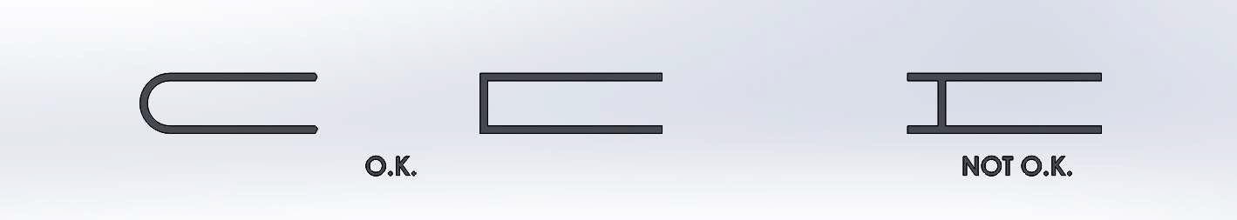

    - It is Recommended but NOT required that Rear bumpers end within 4" of the rear tire as measured inline with the forward direction of the car. If not it is recommended that a Return loop be added to ensure a competitors tire can not become lodged or launched off of your rear tire.

Exhaust System
    - Exhaust system must be complete
    - The exhaust system on all cars must be a minimum of 3” from any tire and is not included in measurements of the overall length of car.
    - The exhaust must exit to the outside of car body (must not exhaust in to an enclosed portion or in a method to trap the gasses near the driver).
    - Clamped on muffler must have a tether and must be in place. Welding of the muffler to the tail pipe is permitted.

Fire Wall and Flooring
    - Full Firewall and flooring must be complete at all times
    - All cars must have a minimum of .030” thickness firewall completely sealing driver from fuel supply, fuel lines, Rear Axle and engine compartment.
    - All cars must have a minimum of .030”thickness metal floor plan with no openings between the driver and ground. The floor pan must cover the complete underside of the driver’s compartment from nose to behind seat or beginning of firewall, in order to shield driver’s body from the ground.
    - Any large openings between floor pan and body must have steel ½” x ½” screening or protective covering to prevent track debris from entering driver compartment.

Fuel Lines and Fuel Tanks:
    - No fuel lines are to be run through the drivers compartment
    - No fuel tanks are to be mounted in the driver"s compartment.
    - Fuel lines must be three (3) inches from any exhaust system.
    - Fuel tanks must be an approved type fuel cell. They may not extend outside of the car, and they must be protected from impact with a steel bar.
    - External fuel tanks must have a shut-off valve and fuel lines must be clamped or safety wired.
    - A spill proof cap must be used to prevent leakage of fuel in the event of a rollover.

Fuel Cell
    - A Fuel Cell is recommended (not required) such as the 2 quart model by JAZ designed for Jr Dragster applications. This model includes internal foam, vent and 1/4" outlet with shutoff valve. JAZ part number 230-050-01.
    - Mounting must be in accordance to all safety regulations.
    - A fire wall is recommended between the Fuel Cell and engine compartment.
    - The Fuel cell must not be mounted in the drivers compartment and a fire wall must separate the drivers compartment from the fuel cell.
    - Roll Over Valve Locations where a fuel cell is not required, a roll over valve is required in the vent of the fuel tank.

Frames
    - All frame welds must be complete: top, sides and bottom.
    - All frames (chassis) must be made of a minimum of 16-gauge (.065”) 1” diameter tubular or (.065) 1” square stock, seamless wall or welded wall, steel or better quality.

    - Cars must have at least two bars (0.65” minimum ¾” diameter), positioned above and outside the driver’ feet and legs to prevent a car from landing on them or entering the driver compartment.
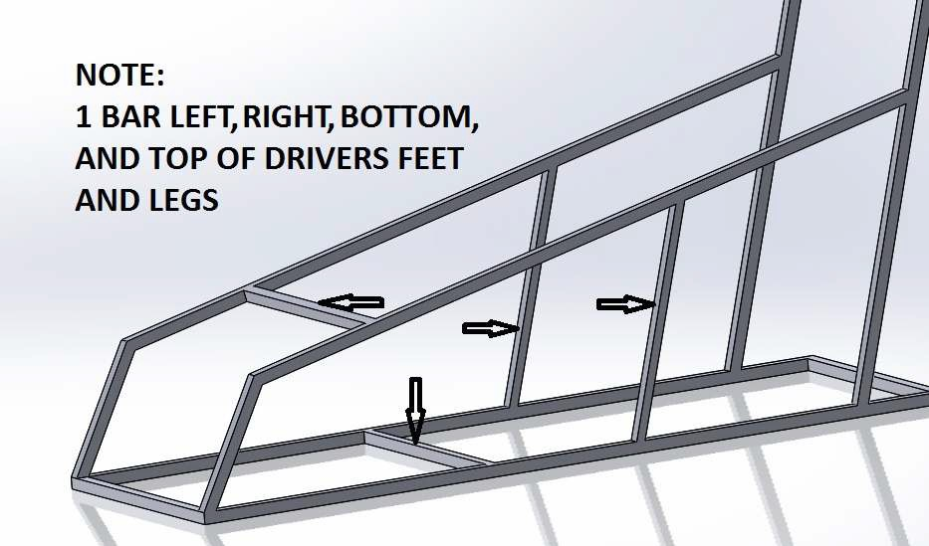

    - Stub axle and axles must be rigidly mounted (bolted or welded) to the chassis such that there is only UNSPRUNG weight. No SPRUNG weight allowed.
    - Hydraulic or pneumatic shock absorbers affecting motion of axles or stub axles are not permitted.
    - A visual check should reveal no springs controlling rotative axle or stub axle motion.
    - All cars must have a footrest or heel stop to prevent feet from sliding out the nose of the vehicle.
    - Side roll cage protection must be made of a minimum of 16 gauge (.065”) ½” diameter tubular, or (.065”) ½” square stock, seamless wall or welded seamed wall, steel or better quality.
      - Sidebars must be placed to prevent intrusion by another vehicle into the cockpit area.
      - All cars must have minimum of 2 sidebars, placed horizontally, vertically or diagonally. Nerf bars cannot substitute for bar protection.

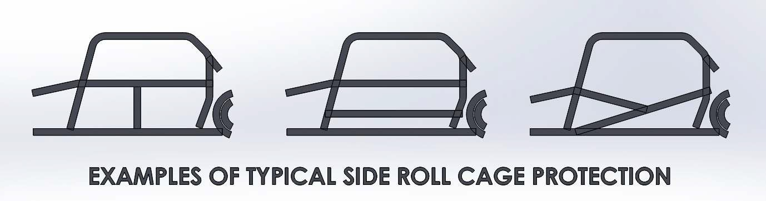

Head Rests
    - All cars must have either a high back aluminum racing seat with integral head rest or a separate head rest cushion.
    - Head Rest With Aluminum Seat The integral head rest on the aluminum seat must be at the approximate height of the center of the driver’s helmet. It must be within the main roll-cage, as viewed from the rear and sides. When in driving position, the back of the driver’s helmet must rest against the headrest.
    - Head Rest Cushion If the seat does not have an integral headrest a cushioned headrest must be mounted directly behind the driver’s head. The cushion shall be mounted so that it is at the approximate height of the center of the driver’s helmet It must be a minimum of 4” and 2” thick. It must be within the roll-cage, as viewed from the rear and sides. When in driving position, the back of the driver’s helmet must rest against the headrest.

Dimensions
    - Height A car may not be higher than 42” or lower than 30”, measured from the ground up (with tires on), to the highest point on the body. Additional roll cages exterior to the body are not included.
    - Width May not be narrower than 37" or wider than 49", measured at any point parallel with the rear axle as if looking straight down. Any protruding body panels are included in the measurement. In the event the violation is a result of an on track incident, it must be repaired prior to further competition.
    - Length A car may not be shorter than 78” or longer than 96”, measured from bumper to bumper.
6.10.3a Length does not include air cleaner or exhaust

  - Weight/weights (All cars competing in MRL and scored)
    - Minimum weight of car after race is 225 lbs. without driver
    - World Formula Class will run a minimum of 475 lbs.
    - Removable ballast must be secured to the welded chassis or other part of the car with bolts and cotter key/safety wire. Ballast must be painted white and numbered to match the car.

Ignition Safety Kill Switch
    - Cars must be equipped with a safety kill switch that will shut off the ignition to the motor.
    - Switch must be accessible within driver’s compartment
    - Must be conspicuously labeled ON and OFF.

Mirrors and Radios
    - No mirrors or radios allowed in car.
    - Receivers are “ONE WAY” and may be required by the local track. They are not considered “Radio’s”
    - Transponders shall be placed 4 foot back (48") from the front bumper unless otherwise agreed to at the track by all competitors.

Nerf Bars
    - All welds must be complete: top, sides and bottom.
    - Must be made of Steel or aluminum.
    - Steel bars Must be made of a minimum of ¾”, .065” tubular or square stock steel and have a minimum of ¾” over rider bar welded on top or a minimum of ¾”, .065” tubular or square stock steel or under-rider bar welded on bottom.
    - Aluminum bars must be a minimum of 1" diameter .100 tubular and have a minimum of 1” over rider bar welded on top or a minimum of 1”, .100” tubular or square stock steel or under- rider bar welded on bottom.
    - Must extend within 2” of the rear tires.
    - Must be within 4” of the rear tires as measured in the direction of travel.
    - Must be a minimum of ½ the length of the wheelbase.
    - Must be welded or bolted securely to the frame.

Oil Catch Can
    - Catch can must be in place prior to competition.
    - An oil catch can, must be mounted inside the body constructed such that oil blow-by cannot leak onto the track.
    - All oil blow-by from the engine breather system must be routed to an Oil Catch Can.
    - The oil catch can, must be vented only to outside air.
    - The total area of all vent lines from the can must be greater than the total area of all lines connecting the can to the engine breather system.
    - Must not leak oil on track.

Fuel Over Flow
    - All World Formula motors must have the fuel overflow run to a catch can.

Roll-Over Bars
    - All welds must be complete: top, sides and bottom.
    - All cars must have a roll-cage with sidebar protection. The main roll-cage must be made of a minimum of 16 gauge (.065) 1” diameter tubular or (.065) 1” square stock, seamless wall or welded seamed wall, steel or better quality.
    - Roll-cage bars must have steel gussets welded in at the four top main joints.
    - All roll-cages must be welded to the main chassis of the car, with gussets at all welded structural joints as appropriate.
    - The roll-bar must clear the driver’s helmet by a minimum of 3”, measuring from a line between the bottom of the roll-bar and the top front of the roll-cage.
There are multiple interpretations of the head clearance rules. This is being included as an instruction on how to make the measurement only as far as was known in 1992. Local track and state rules should be used at all times. This document is not the rule, only a suggestion.
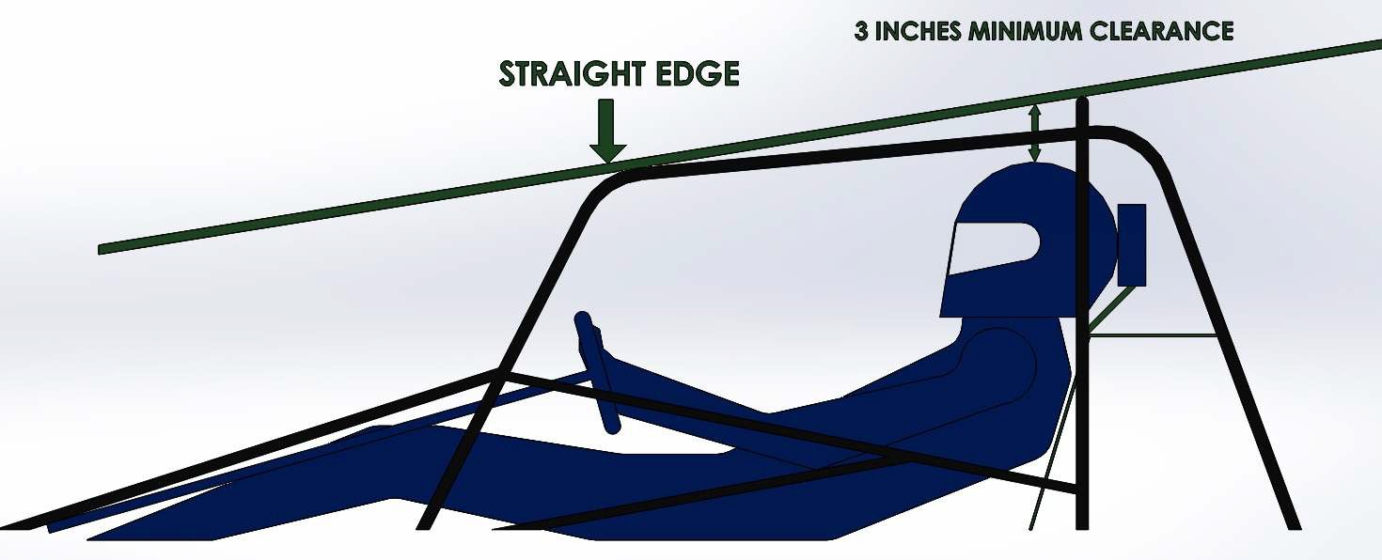

    - Driver’s head and body must be entirely enclosed within the roll-cage and car body.

Safety Belts
    - Cars must be equipped with double over-the-shoulder harness, 3” lap belt and sub strap, with a single quick release.
    - Belts must be fastened to the frame of the vehicle at both ends of lap belt and end(s) of shoulder harness and sub strap.
    - Shoulder belts are to fastened to the frame according to manufacturers recommendation and mounting to be within 6" of the drivers shoulders.
    - All fittings and connections on belts must be metal and bolts, if used, must be grade 5 or better.
    - a If bolts are used they must be cotter keyed
    - “Cam-Lock” type seat releases will not be permitted.
    - Belts must comply with local regulations regarding age from date of manufacture.

Seats
    - All seats must incorporate side and a bottom lip to securely hold the driver in place.
    - Seats shall be attached to the frame of the vehicle, the roll-cage or to a metal plate attached to the frame or base or front of the seat, no more than 4” from the outside edge of the seat at the two most practical widely-spaced points and bolts shall be installed at the two practical widely-spaced points at the top of the back of the seat. The use of a fibreglass seat requires a metal strap at least 2” in width connecting every 2 bolts on the inside of the seat.
    - All bolts must be a minimum 5/16” diameter grade 5 or better.
    - Vehicles with metal seats do not need required straps, but do require fender washers at each bolt.

Steering
    - Cars must have direct mechanical steering with all axle linkage bolts and nuts cotter- keyed or safety-wired.
    - All rod ends must have aircraft quality universal-type swivel joints.
    - Universal joint steering systems must be welded, except where it bolts to a rack. Must be secured safely to rack.
    - Hollow steering shafts must be made of a minimum of .065” steel or better quality tubing.

    - Tie rods may be hollow aluminum or steel or solid steel. Solid tie rods must have a minimum diameter of 5/16” and may have threaded ends.
    - Tie rods made entirely from threaded rods are not allowed.
    - All bolts used on steering components must be cotter keyed
    - Steering wheel must have a quick disconnect and bolts are to be safety wired
    - A 4" diameter 2" thick foam pad is to be mounted on the center of the steering wheel unless the steering wheel is used as a tachometer mount.

  - Tires and Wheels Tires and wheels must be manufactured specifically for racing competition.
    - Maximum wheel diameter not to exceed 6”.
    - Maximum tire diameter not to exceed 15”.
    - Any approved for racing competition tire brand may be run. Local tracks may require a track tire for local or weekly racing.
    - All wheels must be made of quality construction and material approved for racing competition.
    - All wheel axles must be cotter-keyed or C-clipped. C Clips on rear axle are to be wired.
    - Live rear only. No slipper or ratchet hubs-both rear wheels must be fixed. Must use all keys.
    - All cars must start the race with 4 tires, no more no less.

  - Wheelbase Wheelbase may not be shorter than 52” or longer than 68”, measured between the centers of the front and rear axles.

Windshields
    - Required, made of metal screening with a maximum spacing of steel ½” x ½” or clear Polycarbonate, covering entire windshield area.
    - No glass anywhere on car.

Clutches
    - Centrifugal dry clutches only (#35 chain only).
    - Quick-change sprockets allowed.

Chain Guard
    - A Chain guard must be run at all times. The firewall is acceptable as a chain Guard.

Car Safety Items
    - All Steering linkages are to be cotter keyed, safety wired or “safety clipped”.
    - Steering wheel bolts are to be completely wired
    - Brake rotor bolts are to be completely wired or double nutted
    - Caliper bolts are to be wired or double nutted
    - Caliper halves are to be wired together in such a way that the shims do not fall out (if applicable)
    - King pins are to be cotter keyed or safety clipped
    - Rear axle “C” clips are to be safety wired
    - Steering wheel is to have a 2" thick 4" diameter pad mounted in the center
    - All cars are to have a head rest approximately in the center of the drivers helmet, a high backed aluminum seat is to be considered a head rest for cars with such a seat.

Appendix Animal L0-206

L0-206.1 Motor Package
Animal L.O. 206 sealed motor package with 6100 RPM PVL limiting coil. Class regulations reference: http://wwwbriggsandstratton.com/engines-racing/ or 2015 WKA rule book section 207 with the exceptions of the following changes.

L0-206.1.1 Approved Alterations:
No alterations to the internal parts of the motor with the following exceptions No blueprinted motors are allowed. Modification of stock parts is prohibited.
- Animal Throttle linkage “Quick Change” or similar throttle plate may be added.
- All LO 206 motors may use either the factory pull start or the electric starter from Briggs and Stratton
- When using the electric pull start, the manual pull starter can be removed and a screen installed.

L0-206.1.2 Starter: Stock starter or electric starter must be in place at all times.

L0-206.1.3 Battery: If running a battery during competition, Motorcycle (Liquid Filled Vented) batteries must be secured and shielded to prevent leakage in the event of a turnover. If the battery is located within the drivers compartment. Sealed Lead Acid, AGM or other Sealed Dry type batteries do not require a box. The battery shall be secured to the vehicle as to not allow movement of the battery. All bolts must be cotter keyed or wired.

L0-206.1.4a Fuel The Animal L.O. 206 motor is to be run on pump gas 87 octane. No fuel additives or combustible oil additives are allowed. No methanol is allowed. All fuel must test to
+/- 10 points on the fuel test meter. (Fuel supplier may be specified by track officials)

L0-206.1.4b Fuel Lines: No fuel line is to be run through the drivers compartment.

L0-206.1.5 Intake Filter: Air filter must fit carburetor intake without an adaptor. Must be in place at all times. Any air filter meeting these requirements is permitted.

L0-206.1.5b Intake Clean Air Box: Any Clean air intake must be such that funneling of air is not intended or a result. Air filter must remain in the stock location. A box can be constructed around the air cleaner however it must be fully open with the top or side edge and level as not to “scoop” any additional air.

L0-206.1.6 Carburetor: Carburetor must remain in stock un altered condition. Stock jet only (95) is allowed.

L0-206.1.7 Intake Mounting: Rear Engine Microstocks may not invert the intake manifold or run the Animal intake to maintain all motor components within the rear bumper. No alternate intake manifolds will be accepted. No porting, matching or polishing of the manifold is permitted.

L0-206.1.8 PVL For the Animal LO206 class only the green PVL ignition is to be used limiting at 6100 RPM. No alterations of any kind to the stock PVL ignition system are permitted. The black limiting at 4100 RPM, red limiting at 7100 RPM and blue limiting at 12,000 RPM are not to be used in the Animal LO206 class.

L0-206.1.9 Exhaust: Any non moving exhaust pipe is permitted. Exhaust must exit the body work, be at least 3" from any fuel lines and be pointed away from the tires.

L0-206.1.10 Muffler: The only mufflers permitted for the Animal LO206 are RLV part numbers 4104 and 4106. No alterations to muffler permitted. All baffles must remain in place and may not be altered in any way. Welding of the muffler to the exhaust pipe is permitted.

L0-206.1.12 Internal specifications: Internal Animal motor specifications must remain stock and sealed. No alterations of any kind are permitted.

L0-206.1.13 Shrouds and Covers: Engine, flywheel shrouds and covers must be intact and not modified in any way. No additional open holes are to be in any sheet metal shrouds as supplied from Briggs and Stratton. An open hole for a mounting screw in the event the block does not have or is missing the mount is permitted.

L0-206.1.14 ADDITIONAL RULES
ALL OTHER RULES NOT ADDRESSED IN THIS DOCUMENT WILL FALL UNDER THE BRIGGS AND STRATTON 2015 LOCAL OPTION/JUNIOR ENGINE CLASS REGULATIONS OR A.M.S.R.A. RULES. THESE RULES ARE BINDING AND MUST BE FOLLOWED AT ALL TIMES. FAIRNESS, SAFETY, COMPETITIVENESS AND SPORTSMANSHIP IS OUR GOAL WITH THIS ORGANIZATION.

L0-206.2 LO-206 Motor Seals

L0-206.2.1 Seals for the LO-206 class will be done only by Briggs and Statton. No other seals are allowed or recognized.
L0-206.2.2 No competitor is allowed to have the seal tool or un clipped seals in their possession at any time.
L0-206.2.3 Seals done by competitors are illegal and that competitors seals are to be considered void as well as all points removed for any completed races for the season the violation occurs in. L0-206.2.4 Unsealed LO-206 motors will not be allowed to run any sanctioned race
L0-206.2.5 Everything under a sealed portion of a motor is to be considered inspected and passed.
L0-206.2.6 The coil and flywheel key must be inspected before any competition to be considered for points.
L0-206.2.7 Only the green PVL 6100 rpm coil is accepted for use in the LO-206 engine.

Appendix WF

WF.1 World Formula Motor Package
All motors must be stock as produced by Briggs and Stratton unless otherwise specified. No reading between the lines. Any parts in question will be compared to stock parts.

No porting, de-burring or polishing of ports or intake.

WF.1.1 Approved Alterations: No alterations of any sort permitted. Engine must remain as purchased
with the exception of the following.
- Animal quick change throttle plate may be added
- Manual pull starter may be removed and screen installed
- Starter nut for external starter may be installed
- Carburetor Jets may be changed
- Only the “Green” air filter as supplied with the motor is to be used
- Aftermarket pulse type fuel pump may be used, must pulse from stock location on intake
- Updated stock parts may be used (replacing a Gen 1 block with Gen 5 or higher)
- Any Commercially available 10mm Spark Plug may be used
- ARC connecting Rod part number 6247 or 6245 may be used
- Maximum Pop Up of .025

WF.1.2 Starter: Stock starter must be in place at all times. Starter must be operational at the start of competition to receive any points or payout. Starter must remain on the motor.

WF.1.3 Battery: Battery must be in place at all times for competition. Motorcycle (Liquid Filled Vented) batteries must be secured and shielded to prevent leakage in the event of a turnover if the battery is located within the drivers compartment. Sealed Lead Acid, AGM or other Sealed Dry type batteries do not require a box. The battery shall be secured to the vehicle as to not allow movement of the battery. All bolts must be cotter keyed or wired.

WF.1.4a Fuel The World Formula motor is to be run on Pump Gas 98 Octane as recommended by Briggs and Stratton. However with the recent addition of Ethanol to many commercially available fuels, a Racing “pump” Gas is recommended with no aftermarket additives.

WF.1.4b Fuel Lines: No fuel line is to be run through the drivers compartment.

WF.1.5 Intake Filter: Air filter must fit carburetor intake without an adaptor. Must be in place at all times. Any air filter meeting these requirements is permitted.

WF.1.5b Intake Clean Air Box: Any Clean air intake must be such that funneling of air is not intended or a result. Air filter must remain in the stock location. A box can be constructed around the air cleaner however it must be fully open with the top or side edge and level as not to “scoop” any additional air.

WF.1.6 Walbro Carburetor: Carburetor must remain in stock un altered condition. Float height, jet size, and needle height are non Tech Items

WF.1.7 Intake Mounting: Rear Engine Microstocks may not invert the intake manifold or run the Animal intake to maintain all motor components within the rear bumper. No alternate intake manifolds will be accepted. No porting, matching or polishing of the manifold is permitted.

WF.1.8.1 PVL For the WF/CS class only the red PVL ignition is to be used limiting at 7100 RPM. The black limiting at 4100 RPM, green limiting at 6100 RPM and blue limiting at 12,000 RPM are not to be used.

WF.1.9 Exhaust: Any non moving exhaust pipe is permitted. Exhaust must exit the body work, be at least 3" from any fuel lines and be pointed away from the tires.

WF.1.10 Muffler: ONE Modified Muffler permitted. (RLV part number 4106)
No alterations to muffler permitted. Welding of the muffler to the exhaust pipe is permitted.

WF.1.12 Welding: Welding on the block is permitted to repair broken rod damage on sump housing only, no welding on cylinder from cooling fins to top of the block. Weld Repairs of the exhaust stud bolt holes is permitted with no protrusions or modifications allowed to the exhaust port.

WF.2 Motor Seals
WF.2.1 Seals for the WF class will be done by JC. Specialty only. No other seals are allowed or recognized. Any car without a JC seal may compete as “Non-Conforming” but will not be scored.
WF.2.2 Motors sent to JC must be sent complete with carburetor, flywheel cover and intake manifold.
WF.2.3 No competitor is allowed to have the seal tool or un clipped seals in their possession at any time.
WF.2.4 Seals done by competitors are illegal and that competitors seals are to be considered void as well as all points removed for any completed races for the season the violation occurs in.
WF.2.5 Unsealed or Motors sealed by anyone other than JC Specialty are subject to full tear down at the track and cars containing an unsealed motor will not receive any points or payout. WF.2.6 Everything under a sealed portion of a motor is to be considered inspected and passed. WF.2.7 Motor seal numbers must be registered with the MRL and will be verified by JC Specialty

WF.2.8 In the event the shroud seal is missing the coil and flywheel key must be inspected before any competition to be considered for points.
WF.2.9 Only the red PVL 7100 rpm coil is accepted for use in the World Formula engine.

WF.1.13 Rebuilding the World Formula:
Anyone can rebuild the engine. However, once rebuilt it is to be re sealed by JC Specialty.

WF.1.4 Internal Specifications:
Internal World Formula motor specs must remain as stock.
.035 over maximum cylinder bore (on Rebuilds)
Only World Formula Cam and cam profile is permitted. Maximum valve lift when checked with zero valve lash at the spring retainer is .310".
Stock/oversize piston allowed are Briggs part numbers 557121, 557122, 557123,557124 No balancing,
No stroker cranks
Aftermarket connecting rod ARC 6247 and 6245 may be used. No porting
No matching of mating surfaces. Stock head gasket must be used Stock valves must be used
Valve seats may be refinished but must remain 45 degree angle only Stock valve springs must be used
Stock rocker arms must be used Unaltered stock head must be used.
No aftermarket rings (must use stock or oversized stock) No alterations to the stock PVL ignition system
No tampering with the Rev Limiter Rev Limiter must be in working order
No Aftermarket parts permitted internal to the engine.
Head, gasket surface only may be resurfaced. Depth from gasket surface to head surface between valves must be a minimum of .319".
Block, head gasket surface may be refinished. Maximum piston pop-up of .025".

